**The Dizzy Charger:**

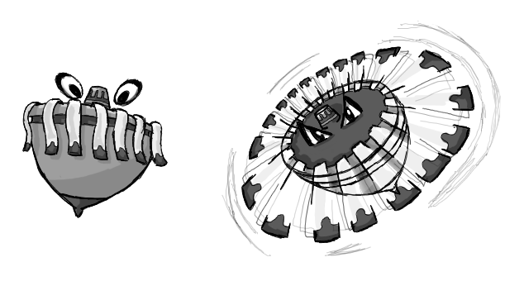

Figure - Enemy: Dizzy Charger

**Brief Synopsis**

The Dizzy Charger is an exceptionally weak enemy that appears in groups, its design is based off a spinning top with ribbons attached to the sides. When the player character is out of range it will rock back and forth on the spot not moving. Once the player comes into range it will begin spinning followed by leaning in the direction of the player and moving towards the position the player was in once they had first come within the range. The effective weapon to use against these enemies would be the **Scythe**, this is due to how little health they have and how they appear in large groups.

**Variants**

To differentiate these variants the ribbons colours will alter,   
 **Blue and Silver Ribbons:**

* The enemy will move in a straight line towards the position that the player was in when they first entered this enemy’s line of sight.

**Red and Gold Ribbons:**

* This enemy would continuously home in on the player, slowly correcting their trajectory to head towards the players current position, these would still not avoid obstacles and would die upon hitting them

**AI**

The Pathfinding this enemy will simple as it will only move straight towards the player and not try to avoid obstacles. If this enemy collides with an obstacle before it hits the player it will stop in its movements and die.

**Animations**

The Dizzy Charger will have three states, idle, death and attacking. There will be a single transition animation between these.  
 **Idle:**

* Rocks back and forth on the spot, no actual animations needed, (unless having the ribbons affected by gravity).

**Idle -> Attacking:**

* The model is span at an increasing rate until a max rotation speed is reached, as this is happening the ribbons straighten out like helicopter blades.

**Attacking:**

* Model is just rotated on its axis, the and tilted in the direction its moving.

**Death:**

* It will explode.

**Average Size**

